THERMOMETERS
Quill | 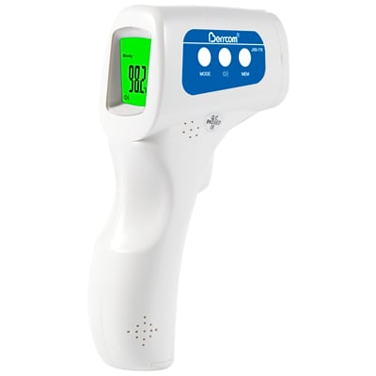  Non-Contact Infrared Thermometer (JXB-178) | Item is not returnable or refundable  Fast and accurate reading from within 2-3 inches of the forehead  3 color backlit screen for easy identification - green for normal temperatures, orange for low fevers, and red for high fevers | $59.95 limit 5 |  | Jerard Bailey | Jerard.Bailey@Quill.com | 1800-789-7020  Ext. 1440
MSESC | No-Contact Infrared Thermometer |  | $70.00 each  Over 500 units - $60.00 each |  | Jan Hanlon |  | 304-766-0011

